Project Proposal

On

**House Rental Management System**

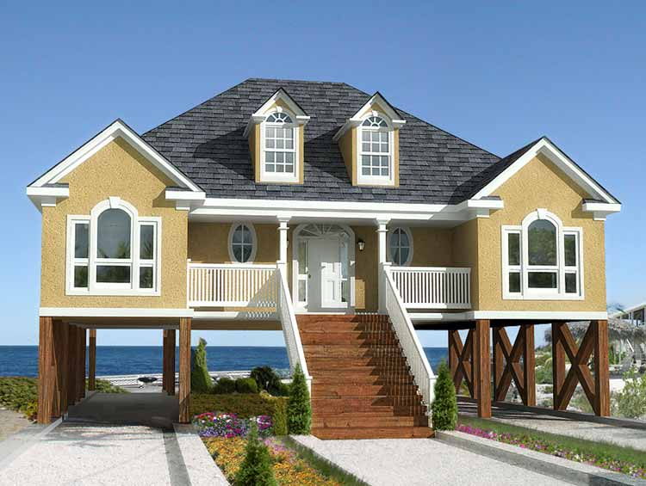

Sahara Magar

00175857

Computing Project

Level 5 in Computing

Softwarica College of IT and E-Commerce

Kathmandu, Nepal

01/07/2019

Submitted to: Sudeep Bajimaya

1. INTRODUCTION 4-5

1.1 Introduction of the Project 4

1.2 Back ground of the sysstem 4

1.3 problem statement [4](#_Toc534486081)

1.4Overview of the proposed system 4-5

2. Project Scope 5-6

2.1 Aims 5

2.2 Objectives 5

2.2 Features 5-6

3.Development Methodology 6

3.1 Methodology used 6

3.2 Design Pattern 6-8

3.3 System Architecture 9

4. Work Breakdown Structure (WBS) / Scheduling 10-14

4.1 Work Breakdown Structure 10

4.2 Milestones 11-12

4.3 Gantt Chart 13-14

5. Risk Management 14-16

6. Configuration Management 16-18

7. Conclusion of the project 19

**List of figures**

Figure 1: Waterfall Model …………………………………………...7

Figure 2: Model View Controller ……………………………………………8

Figure 3: 3-Tiers Structure ………………………………………………9

Figure 4: WBS Structure ………………………………………………10

Figure 5: Days division for Tasks ………………………………………………11

Figure 6: Gantt chart of House Rental Management System …………………………………………14

Figure 7: MBS on GitHub …………………………………………14

Figure 8: Tree Structure of MBS …………………………………………15

**1.1 Introduction**

Rental house management system is the system for management of the renting system of the house. House is the basic need to the people for living. So, to make the easy life style and easily accessible for all the people house rental system is introduce which can provide all the needed facilities. We also make it mobile friendly as, users can search for the reliable and vacant house and can transport any time. Tenants can search randomly according to their wish based on unique area and city.

**1.2 Background to the system:**

House rental management system is the web portal in which the tenants search for the house in rent with all their needed facilities. You can book the hose in rent and also make the online payment for the house. Also can add wish list if their desired home is not available. You can also see the house according to your budget range. You can also chose the location and can view the area around the house as it is near the office area, school, factory etc.

In our system we also apply the option whether you want the house for family or bachelor implement IOT for more efficient.

We also provide the safe and user friendly platform for the bachelor so that they can rent the house efficiently wherever they want with all their features.

**1.3 Problems statement:**

Many problems were find during the search for the house in rent as, you have to visit the respective location. It may be difficult for the tenants because different house may be located at different places which may be difficult for them to visit each house. They don’t have to be presence in order to make the payment of the rent as online payment can be done.

Through this system they can easily visit the site and see all the houses at different location. Now they will be able to see the different houses at their desire budget. They will also get the houses for certain period and long period of the time. All the information of the houses will be updated as per the changing rate of the business.

**1.4 Overview of the proposed system:**

The system includes the whole rental management. It also provided the different services according to the requirement of the customers. Helps to find the different and their desire house in their desire location with major facilities in reliable price. Also the bachelor and family home services are different with security.

Tenants can also online booked or reserved the house which can save their time and cost. They can also made the online payment of the house. They can also easily search the location of the house which they are willing to buy and can also see the review from others in comment box.

**Chapter: 2 project scope**

**2.1 Aims:**

1. The aim of the project is to book the house or search the efficient house from browsing the website by sitting anywhere at any time.
2. Is to provide the proper and updated information about the house rent.
3. Aims to find the reliable, comfortable home in fix date and time.

**2.2 Objectives:**

1. To develop a system that allows the users to view the customer’s data as well as house records.
2. Develop a system that allows the users to add, edit, search, and delete the data from the database.
3. To manage all the house rent, client.
4. To analyses the requirement specification of the client.
5. To produce the system which helps the client for easy payment through online booking.
6. To ensure the security that unauthorized people cannot get access to the personal data.

**2.3 Features:**

1. Welcome form (Admin/users login form).
2. Online booking/payment form.
3. Tenants registration record form.
4. Google map/location.
5. Dynamic rental search.
6. Dynamic mail system.
7. Tenant’s feedback and comments.
8. Contact form.

**Chapter: 3 Development methodology:**

**3.1 Methodology to be used:**

I have used waterfall methodology for this project. As, waterfall uses the analyzing , designing, implementation , testing and deployment phases this can be completed and can’t take a longer time to finish as time is already estimated for this .

This is the first approach uses in software development. This model is the step wise or sequential model in which the one step must be finished before starting the other step.

Firstly the requirement is gathered, collected and documented. System is then designed and model as per the requirement. The source code is developed using the model, logic and requirement then the system is designed in smaller component or unit.

Each unit is tested in testing phrase which is known as unit testing. After finishing all the testing of functional and nonfunctional part the system then it is provided to the client in deployment phase. In this project users are unlikely to change their requirement as their requirement is already specified. Once the one phase is completed then we cannot go or make changes to the other phase.

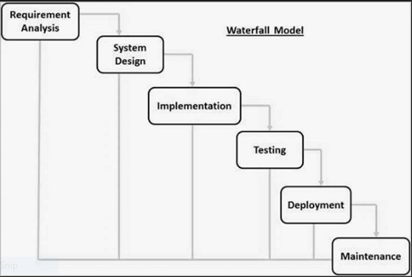

Figure 1Waterfall model

**3.2Design pattern:**

Design pattern in general is the reusable solution to a commonly occurring problem with in given context in software development .Design pattern Design patterns may be viewed as a structured approach to computer programing.

Design patterns can speed up the development process by providing tested, proven development paradigms. The design pattern that will be using in this project is MVC design pattern. MVC is the mostly used design pattern in the today market. It consist of three parts that is model view and controller. Each part is not dependent on other part.

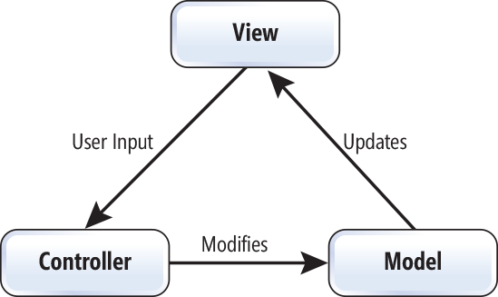

Figure 2 Model View Controller

**Model:**

Model represents the model or shape of the database in which the users works. It also interact with the database. It also the data been transfer between view and controller.

**View:**

View represent the user interface (UI). It also display the data with the help of model and also enable or help them to modify the data.

**Controller:**

Controller manage the user’s requests. It acts as the intermediary between view and model in which the incoming request and logic are proceed.

**3.3System Architecture:**

The system architecture that will be using for this project will be 3-tire. System Architecture is the conceptual model which only defines the structure, view and behavior of the system. The description of the whole system is done by this architecture. 3-tire is the flexible and faster the application. It is 3-tire structure is describe bellow.

1. Presentation tire:
2. Application/Business tire:
3. Data tire:

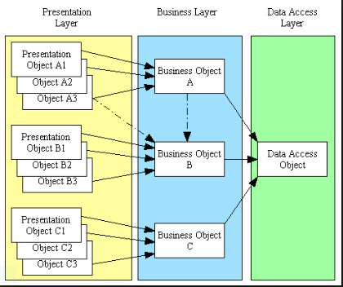

Figure 3-tier Architecture model

# 4. Work Breakdown Structure (WBS) / Scheduling

## 4.1 Work Breakdown Structure

Work break down structure is the process of breaking down the complex work or project into a simple or manageable component. It is usually used by the project manager for the work division to the respective person. It is the hierarchical decomposition of the work. Dividing of the work helps in better planning and organizing the work.

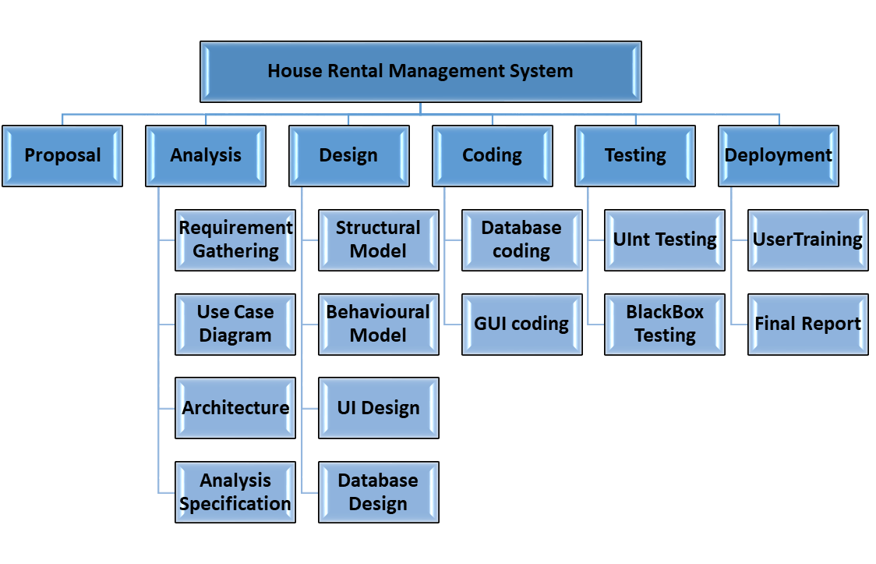

Figure 4Work Break Down structure

## 4.2 Milestones

|  |  |
| --- | --- |
| **Milestone** | **Date** |
| **Proposal** | 2019/6/26 to 2019/7/2 |
| **Analysis**  Requirement analysis  Use Case  Architecture (Initial Class Diagram)  Analysis Specification | 2019/7/3 to 2019/717  2019/7/18 to 2019/7/25  2019/7/26 to 2019/7/31  2019/8/1 to 2019/8/5 |
| **Design**  Structural Diagram  Behavioral Diagram  UI Design  Database Design (ER , Data Dictionary) | 2019/8/6 to 2019/8/13  2019/8/14 to 2019/8/21  2019/8/22 to 2019/9/3  2019/9/4 to 2019/9/11 |
| **Implementation**  Building Database  Coding | 2019/9/12 to 2019/9/18  2019/9/19 to 2019/10/4 |
| **Testing**  Unit Testing  Black box Testing | 2019/10/7 to 2019/10/11  2019/10/14 to 2019/10/16 |
| **Deployment**  User Training  Final Report | 2019/10/17 to 2019/10/22  2019/10/23 to 2019/10/29 |

**Description of Milestones**

**Proposal: (5 days)**

I have allocated 5 days for the proposal of the project.

**Analysis (24 days)**

I have allocate total 24 days for this task i.e. 11 days for requirement analysis, 6 days for Use case diagram, 4 days for Class Diagram, 3 days for Analysis Specification.

**Design (27 days)**

I have allocate total 27days for this task i.e. 6 days for Structural model, 6 days for Behavioral model, 9 days for UI design, 6 days for database design.

**Implementation (17 days)**

I have allocate total 17 days for this task i.e. 5 days for database build and 12 days for coding.

**Testing (8 days)**

I have allocate total 8 days for testing i.e. 5 days for unit testing 3 days for Black box Testing.

**Deployment (9 days)**

I allocate total 9 days for this task i.e. 4 days for user training and 5 days for Final Report.

**4.3 Scheduling / Gantt chart**

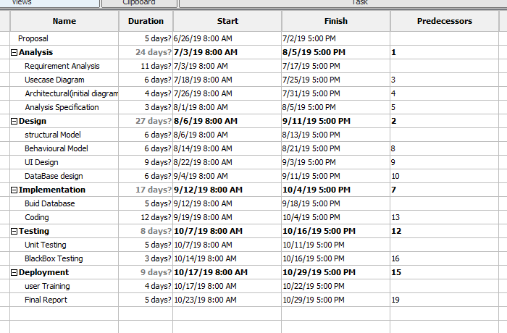

Figure 5 Days Division for Task

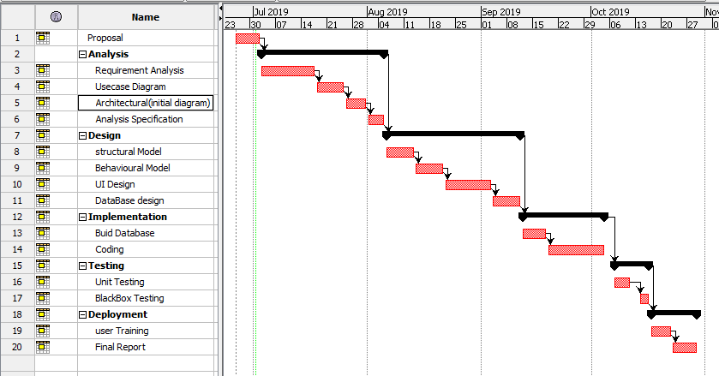

Figure 6: Gantt Chat for House Rental Management system

# 5. Risk Management

Risk management is the process of identifying and controlling or minimizing the threat in the company or organization. It should be done in the initial phase i.e. in planning phase in order to avoid the future consequences or risk.

Following are the method to control risk in Project Management.

Avoidance:

Reduction:

Sharing:

Retention:

**Impact = Likelihood * Consequence**

Risk Likelihood values are shown as follows

|  |  |
| --- | --- |
| Likelihood | Value |
| Low | 1 |
| Medium | 2 |
| High | 3 |

Risk consequences value are shown in the table below:

|  |  |
| --- | --- |
| **Consequences** | **Value** |
| Very low | 1 |
| Low | 2 |
| Medium | 3 |
| High | 4 |
| Very High | 5 |

Risk consequences is shown in the below table;

|  |  |  |  |  |  |
| --- | --- | --- | --- | --- | --- |
| S.N | Risk | Likelihood | Consequences | Impact | Action/solution |
| 1 | Resources are insufficient | 2 | 3 | 6 | First all the analysis of the required resources should be done. |
| 2 | Failure of the Hard disk | 1 | 5 | 5 | Back up of the data should be done. |
| 3 | Time and Budget shortage | 2 | 4 | 8 | Cost and time estimation should be done according to the requirement |
| 4 | Requirement does not meet | 2 | 5 | 10 | Project planning should be done properly. |
| 5 | Problem of scheduling | 2 | 4 | 8 | Division of the task should be done as per the priority. |

# 6. Configuration Management:

CM is the practice of handling changes systematically so that a system maintains it integrity over time. It also refers to the system which track software, hardware and related information of the system. It programs and plans provide technical and administrative direction to the development and implementation of the procedures, functions, services, tools, processes, and resources to develop and support a complex system.

The following point can shows why the configuration management should be used.

* With the use of CM we can have the structured and effective methodology for documentation, validating, releasing and changing the requirement in the business.
* Helps in team coordination.
* Any changes and updates are transparent with in the team.
* Cost reduction as by having all the element configuration information and detail already can reduce the UN necessary duplication.

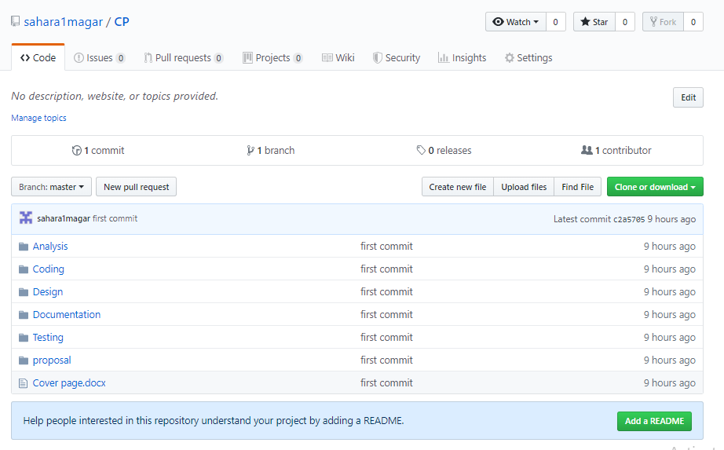

Figure: 7HRMS in GitHub

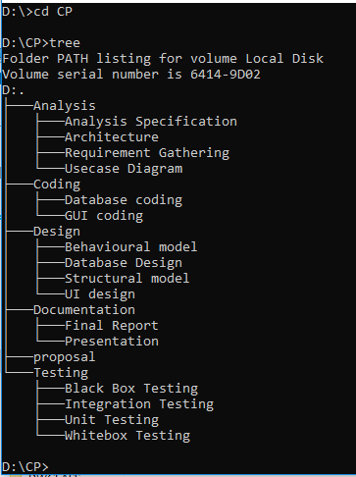

Figure 8: Tree structure of HRMS

# 7. Conclusion of the project

House rental management system is the user friendly web application through which the users can booked, search and view property. They have to get login to the system to book the property. With the different types of the features the overview of the project is shown. Waterfall methodology and WBS diagram is also used for the project decomposition. Breakdown of the work also done with the scheduling of the time Gantt chart has been used. Prioritization of the work is done show that the functional requirement is first full filled. Different types of the diagram was done which shows the system structures. Sequence diagram, activity diagram, Er diagram and class diagram was drawn which represents the structure of the system. Helps link is also available through which users can get help in using the system. Any doubt in using the system can be clear by using the help button. Any users can sent the mail to the admin. The users will be notified if they provide the valid information then they will get the mail if their booking are conformed or not. So, this system will helps the users who are willing in searching the reliable house which can saves the cost and time of the users.

References:

TutorialPoint. (2018). Retrieved from <https://www.tutorialspoint.com/sdlc/sdlc_waterfall_model.htm>

<https://www.softwarequality.techtarget.com>

https://www.tutorialsteacher.com/mvc/mvc-architecture

Watt, b. a. (2018). Retrieved from https://opentextbc.ca/projectmanagement/chapter/chapter-16-risk-management-planning-project-management/

https://en.wikipedia.org/wiki/Configuration_management